- Login to the server and create ODBC connection to connect with DB.
- Go to start ODBC Data Source Administrator (32-bit)
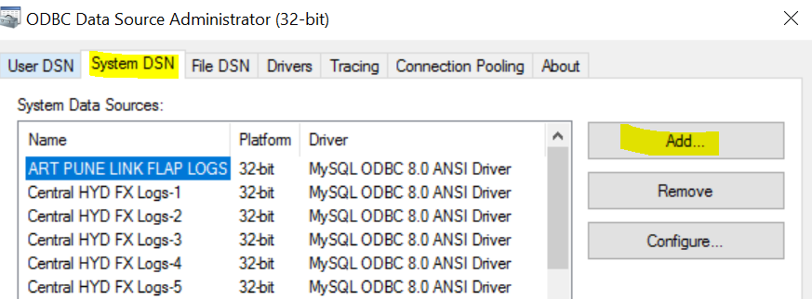

- System DSN ADD Select MYSQL ODBC 8.0 ANSI Driver

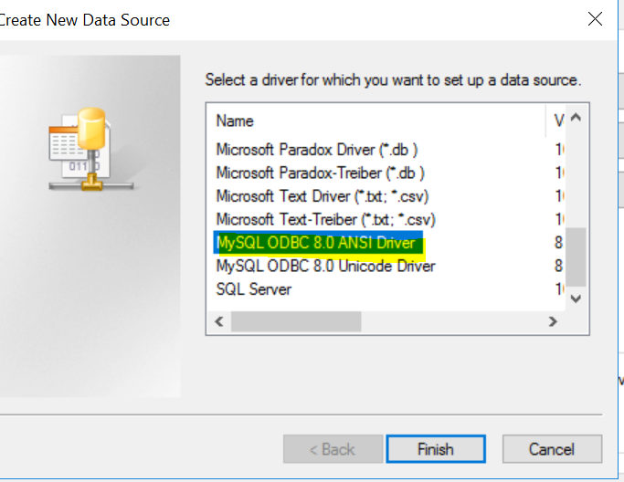

- Fill the details and select database which is already created by DBA team.
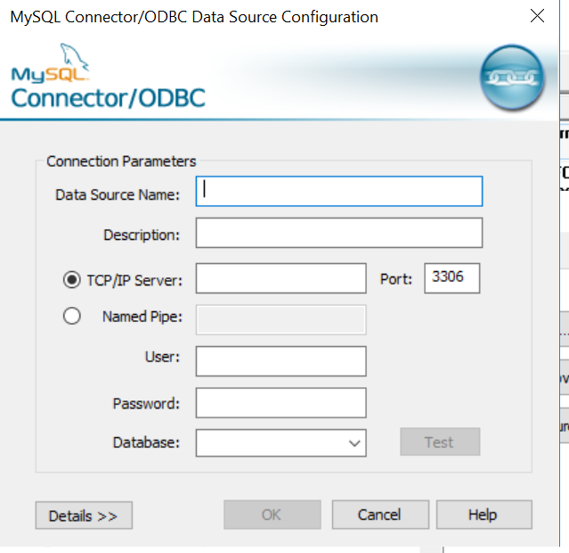

Example:
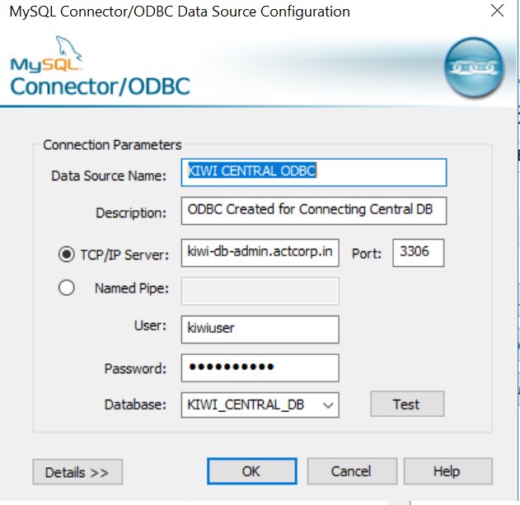

- Once ODBC connection is ready, now we can create rule in KSS application.
- Go to filesetupRight click on Rules and click on Add rule.
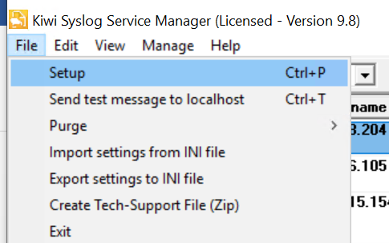

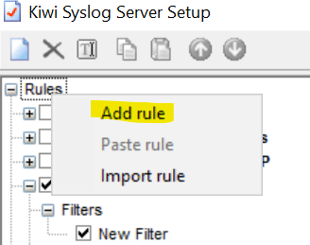
7. Give rule name in standard format.
8. Right click on Filters and create file in standard format
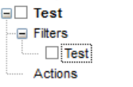
9. Chose field, Filter type and fill the details based on selection type.

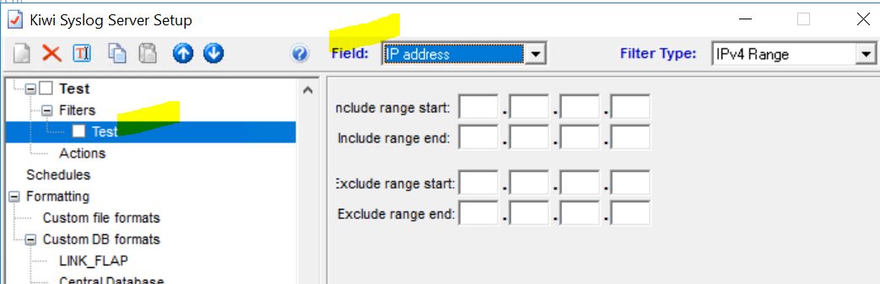

10. Right click on Filters and create on more filter as message and choose message text in field and include the required message signatures.

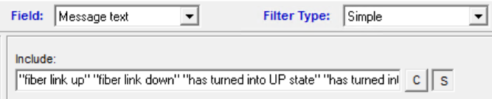

11. Right click on action and add action for DB.
12. Choose datalink connection string based on ODBC creation which is already created in the first step.
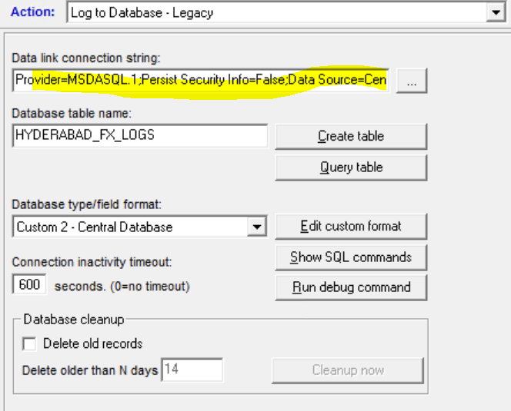

13. Go to connection and select use data source name which created in the first step and click on test connection.
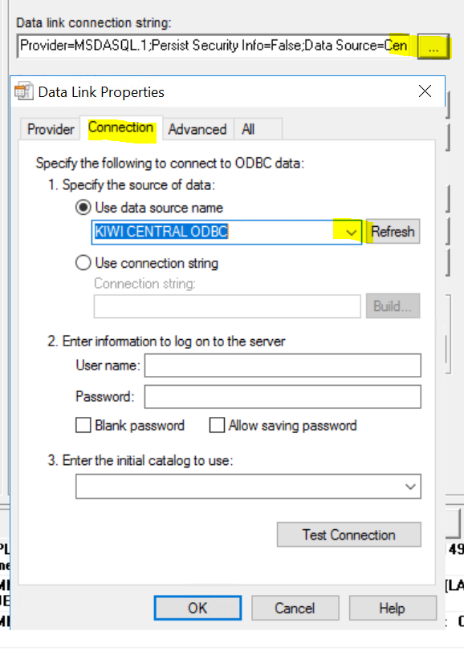
14. Give standard Database table name and click on create table.

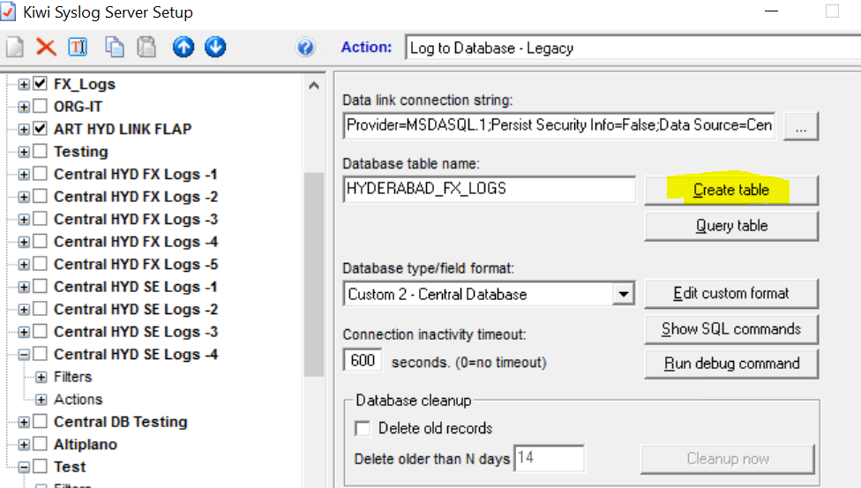

15. Then chose the custom database type/field format and click on Test.
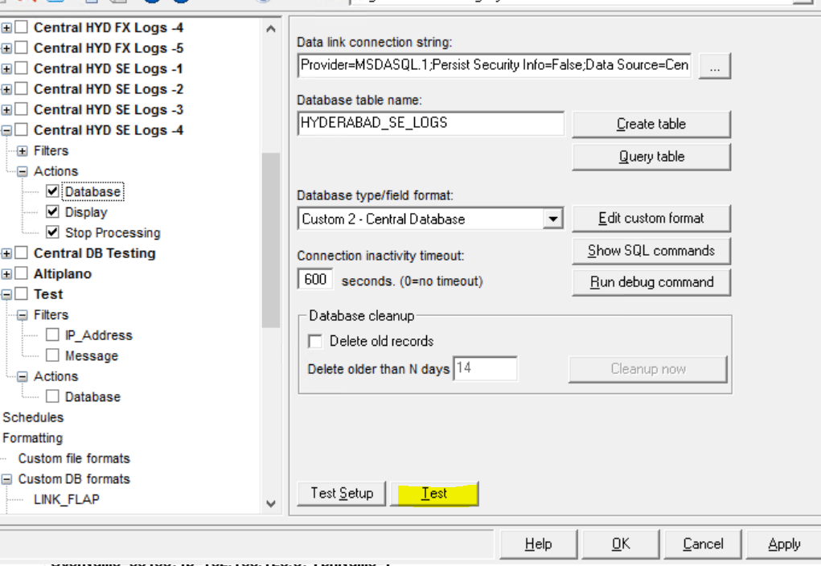

16. Creation for custom database type/field
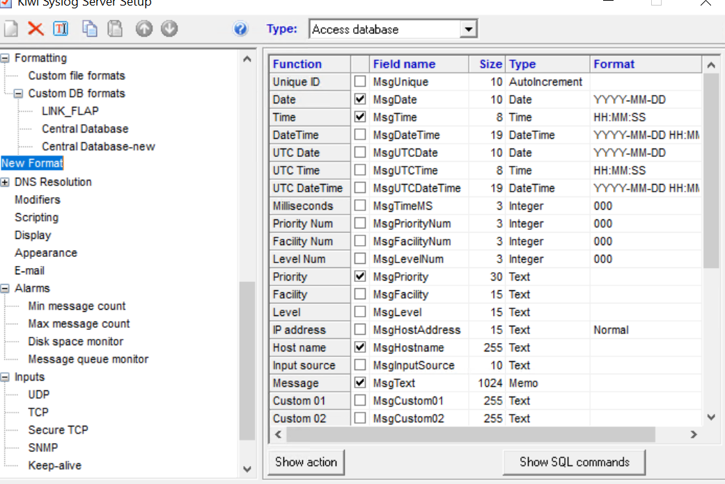

17. Right click on action and create display action.
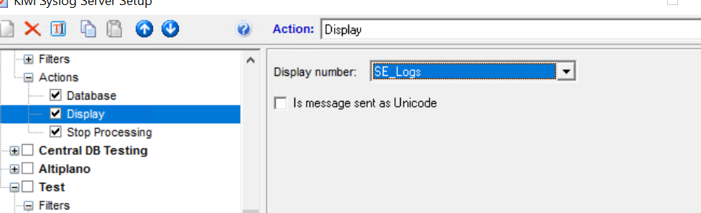

18. To create standard display name, go to display and choose modify display name, enter the standard display name and click on update.

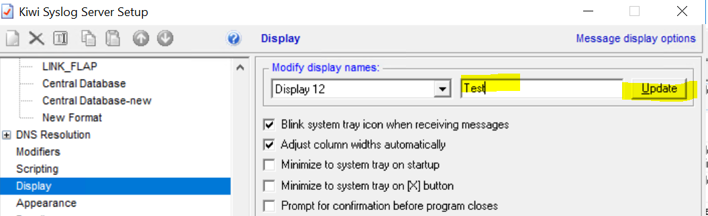

19. Now to connect DB and verify the logs, use the heidisql.
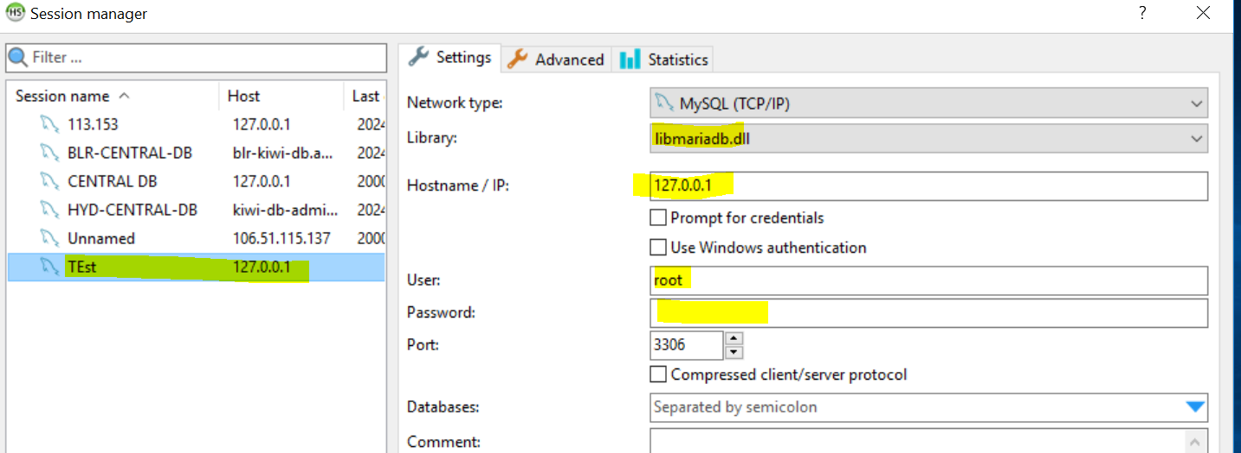

20. Fill the details and click on open and check the logs.

